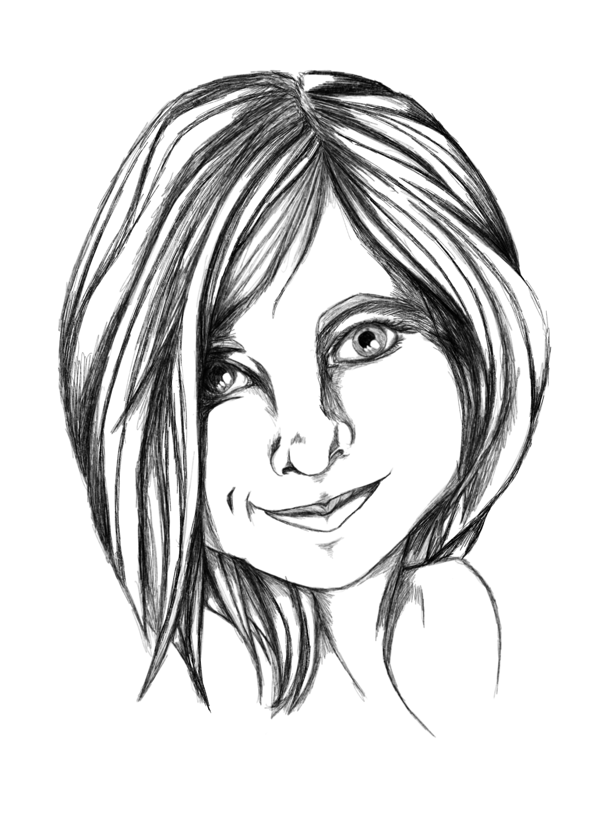
Milo
The imaginative younger sibling
Strength: Joy of life - Object: Soap bubbles
Main relation: younger sibling to Nor

I am the younger sibling and my strength is the joy of life. Life is about playfulness, and I’m here to get the most out of the journey. I kinda know that the world has its darkness, but I don’t yet know the debts of it. It’s my smile and laughter that keeps the others believing that there's still light in the world.

What the others think of me:
The youngest on our group, and Nors younger sibling. Somewhat irresponsible but always excited about the world and life. Milos good mood is very infectious even though it can become a bit silly at times.

Relations
Main relation: Nor - Strength: Caring - Object: Blanket - Nor is my elder sibling and I really look up to Nor. I know that Nor takes good care of me. Maybe a bit overprotective at times. If only I could prove that I really can handle myself.

Issa and Levi
It seems that Issa and Levi like each other a lot. Everyone can see it except themselves.
- Issa - Strength: Trust - Object: teddy bear - About as old as Nor and Levi. A child from the richest family in Homestead. But you can’t tell, except that Issa might be a bit naive at times. But that is only because Issa always believes in the best in people. It feels good to be trusted by Issa.
- Levi - Strength: Stubbornness - Object: a granite rock - Levi is an orphan but isn’t held back by that, or any thing else. Levi might not look like much, but don’t be fooled, Levi can will survive all the trials of life.

Eli and Val
Eli and Val are best friends exactly because of their differences.
- Eli - Strength: Hopeful - Object: a light - Eli and Val are the oldest on our group, and therefore kinda our leaders. But it is well earned. Eli is always looking towards far horizons, and can talk forever about all the adventures that we will have.
- Val - Strength: responsibility - Object: A bottle of water - Val is Elis opposite, and that is why they do so well together. Val is focused inward towards Homestead and our group. Vel will never let us down, and takes the responsibility as eldest very seriously.

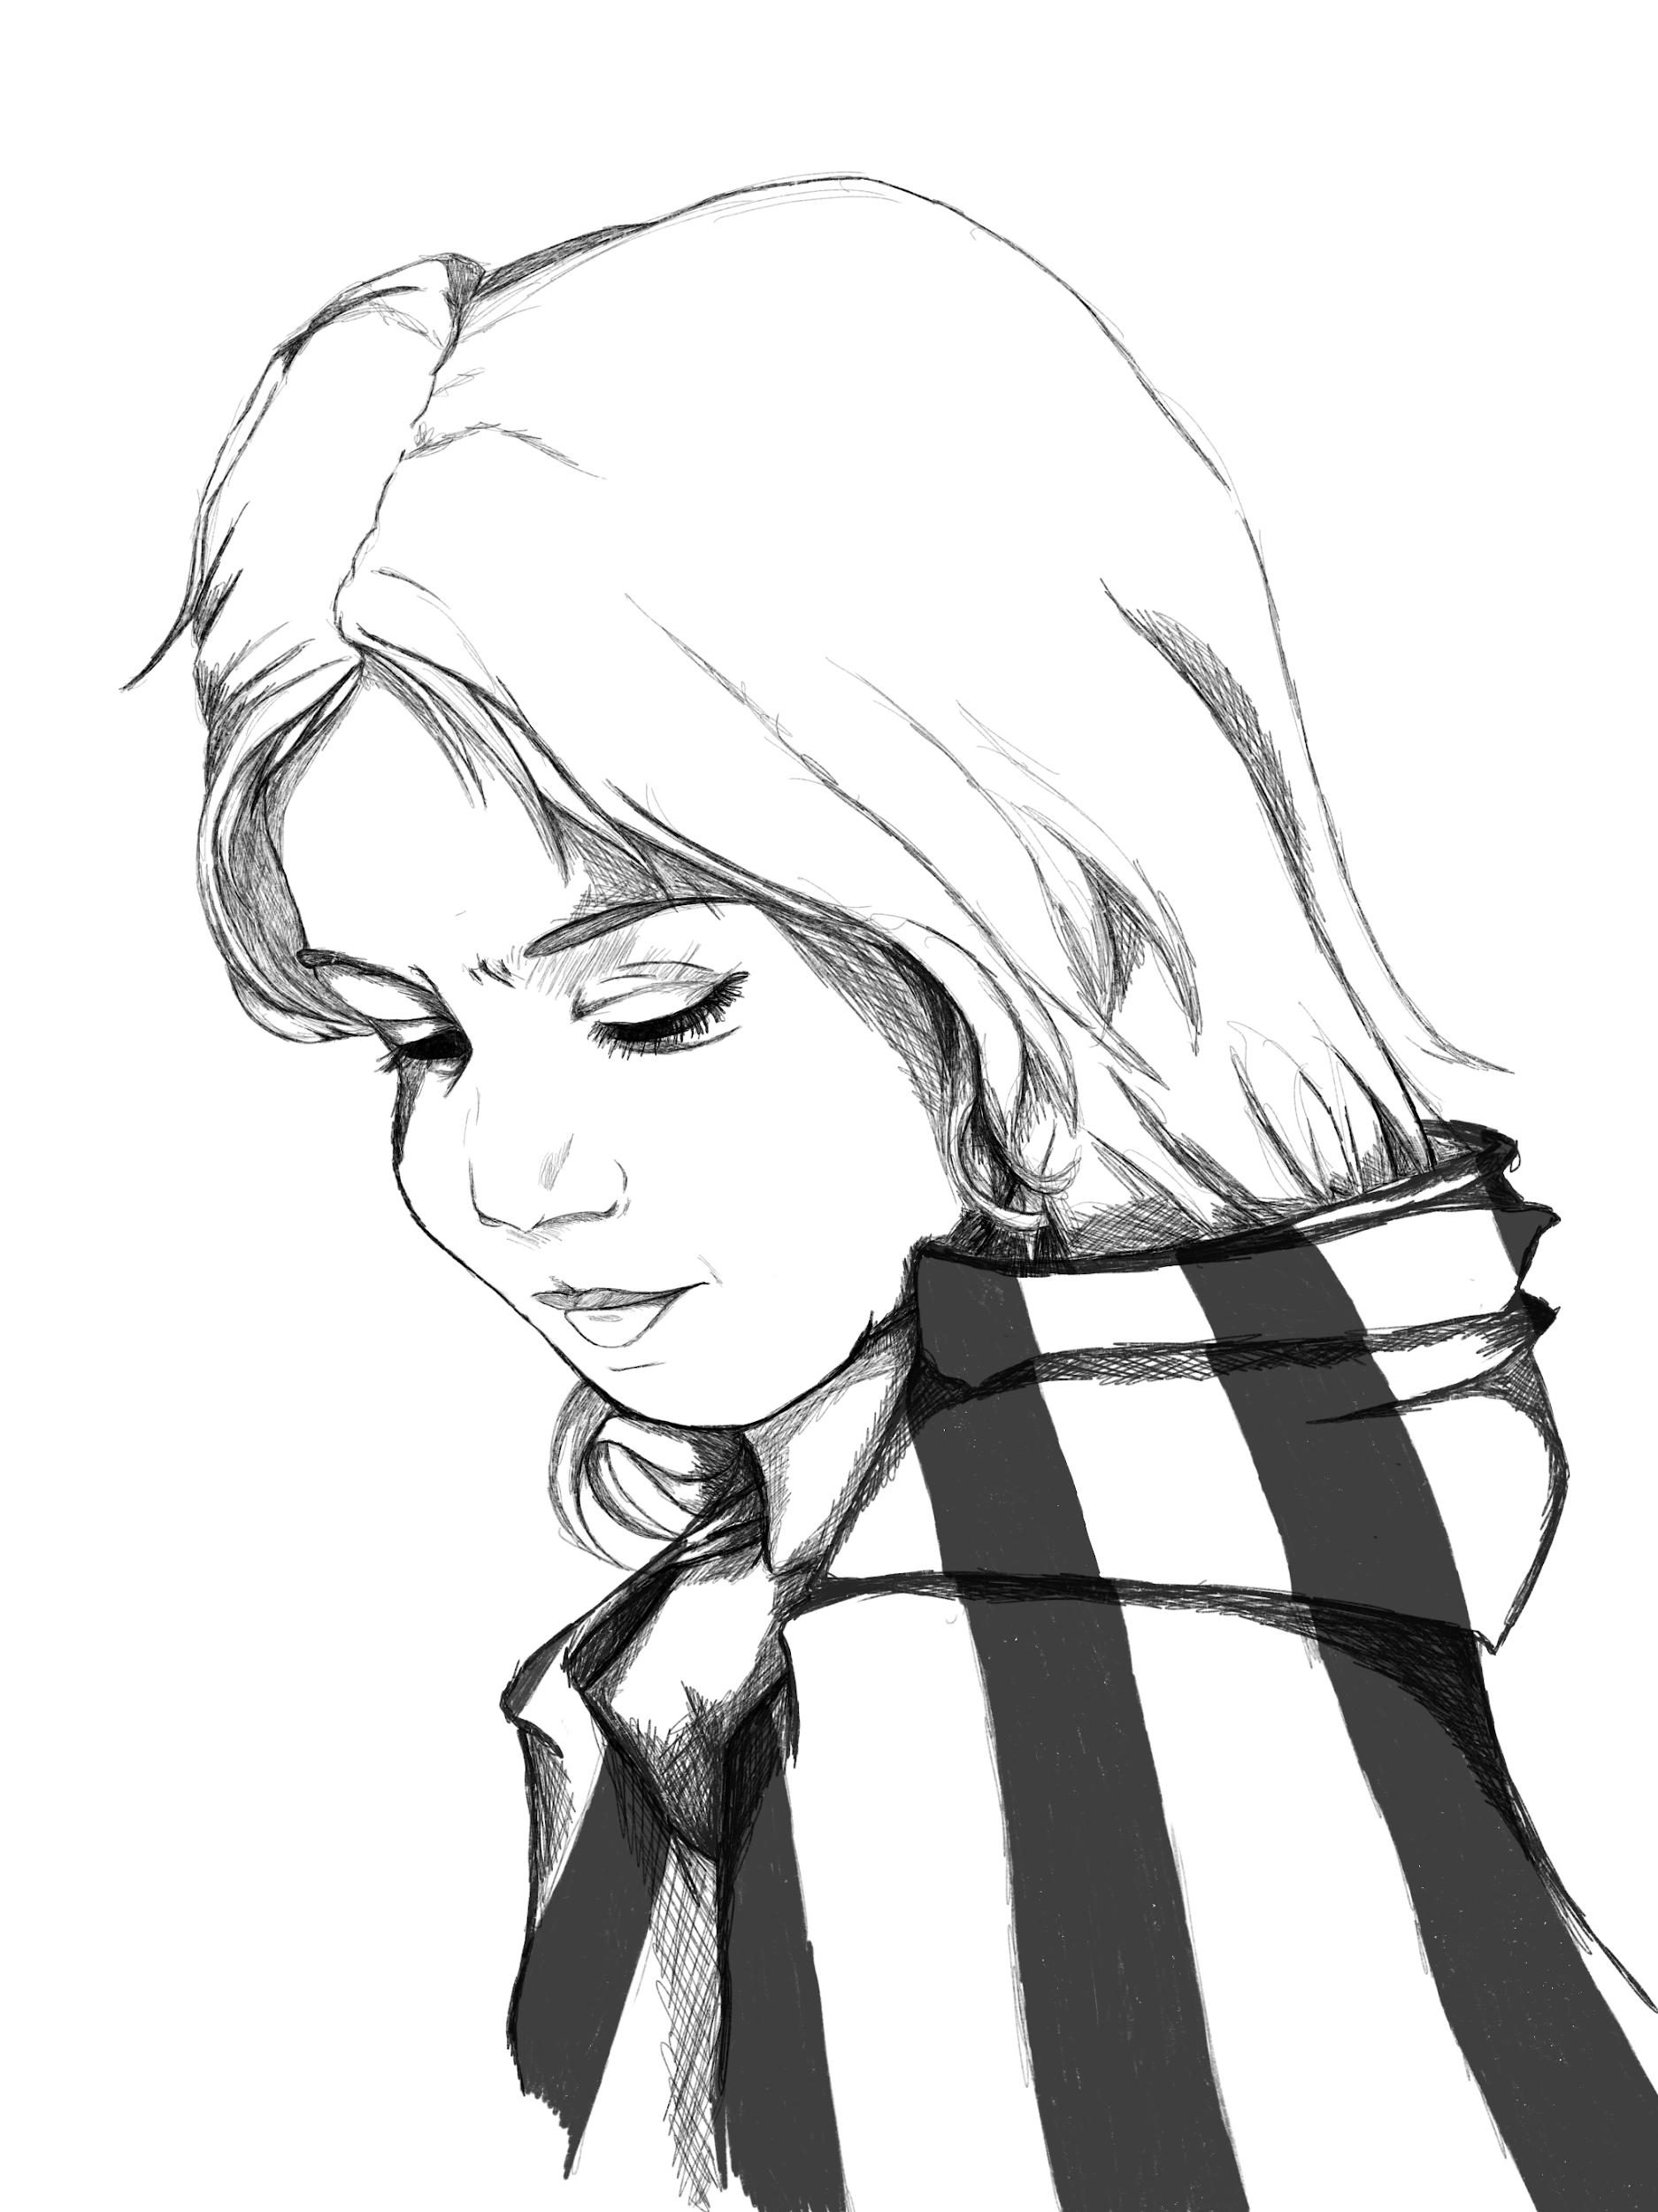
Nor
The protective older sibling
Strength: Caring - Object: Blanket
Main relation: Older sibling to Milo

I am the older sibling and my strength is caring. I’m still a child, but I know what it means to take care of others. I love my younger sibling and I will do anything to protect Milo from the darkness of the world. This caring stretches to all my friends and I will always share with them the warmth underneath my cloak.

What the others think of me:
About the same age as Issa and Levi and is the older sibling to Milo. Nor always takes good care of Milo, and all of us come to think of it. If you are in need of care and support then you go to Nor.

Relations
Main relation: Milo - Strength: Joy of life - Object: Soap bubbles - My younger sibling Milo means everything to me. I will go to the end of the world and back again for Milo. There’s no one as happy and smiling as Milo, and that spirit must be preserved at all costs. Milo is the youngest in our group.

Issa and Levi
It seems that Issa and Levi like each other a lot. Everyone can see it except themselves.
- Issa - Strength: Trust - Object: teddy bear - About as old as Nor and Levi. A child from the richest family in Homestead. But you can’t tell, except that Issa might be a bit naive at times. But that is only because Issa always believes in the best in people. It feels good to be trusted by Issa.
- Levi - Strength: Stubbornness - Object: a granite rock - Levi is an orphan but isn’t held back by that, or any thing else. Levi might not look like much, but don’t be fooled, Levi can will survive all the trials of life.

Eli and Val
Eli and Val are best friends exactly because of their differences.
- Eli - Strength: Hopeful - Object: a light - Eli and Val are the oldest on our group, and therefore kinda our leaders. But it is well earned. Eli is always looking towards far horizons, and can talk forever about all the adventures that we will have.
- Val - Strength: responsibility - Object: A bottle of water - Val is Elis opposite, and that is why they do so well together. Val is focused inward towards Homestead and our group. Vel will never let us down, and takes the responsibility as eldest very seriously.

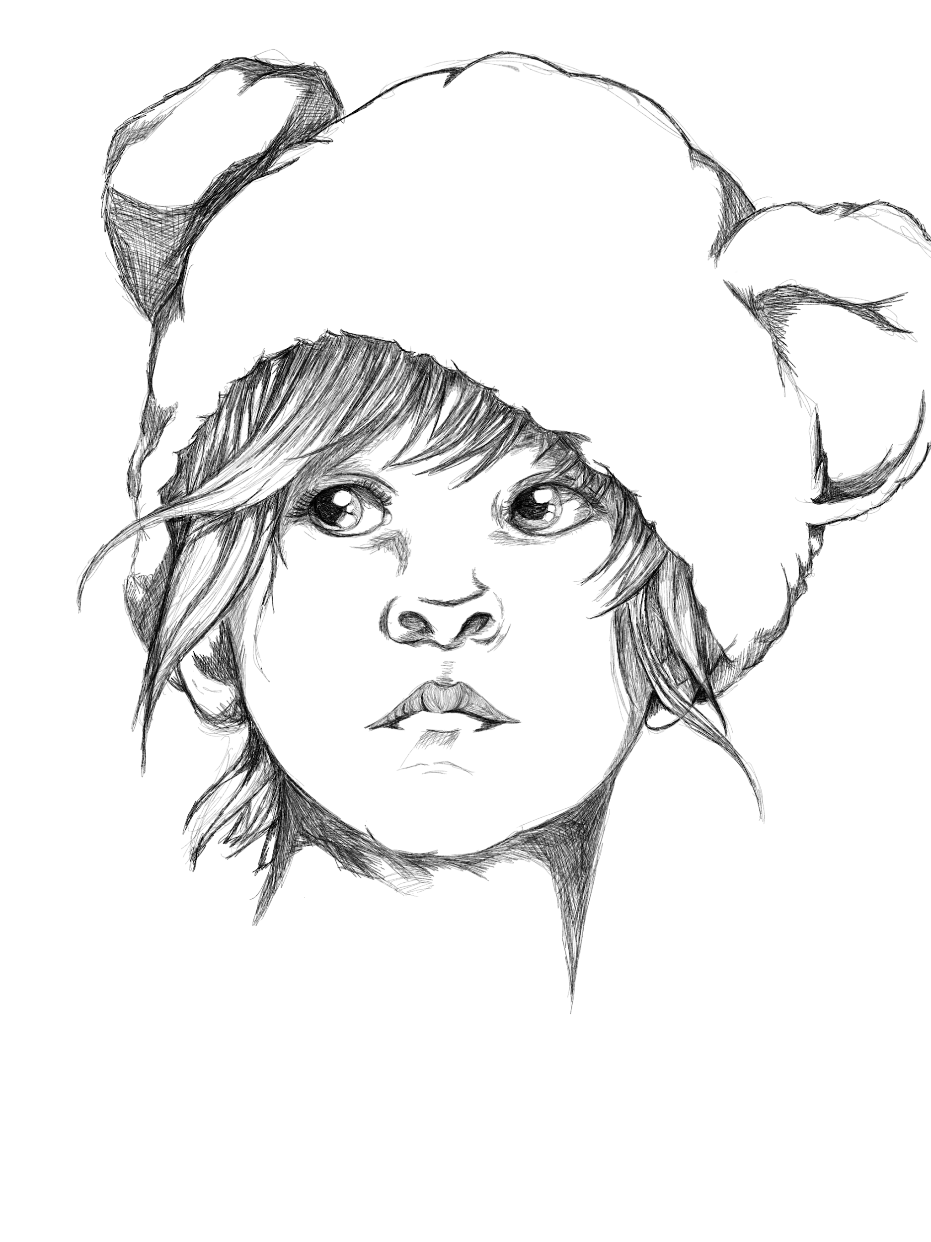
Issa
The privileged child
Strength: Trust - Object: teddy bear
Main relation: secretly in love with with Levi

I am the privileged child, and my strength is trust. I have lived a protected life. I have heard about evil and people being cruel, but I believe that there is some good in everyone. If you show people trust, they will try and live up to that trust. This might sound naive but I truly believe in the good in humankind.

What the others think of me:
Issa is from the richest family in town, but you really can’t tell, other than the fact that Issa can seem a bit naive at times. But that is only because Issa believes the best in people. It feels good to feel Issas trust in you.

Relations
Main relation: Levi - Strength: stubbornness - Object: Granite stone - I think, I’m in love with Levi. But we come from such different worlds. Levi is an orphan and have gone through so much already and still keeps on going. Levi must of course never know of my feelings, because Levi would never be interested in someone as spoiled and naive as me.

Milo and Nor
Milo og Nor are siblings. They may disagree a times, but they care deeply for each other.
- Milo - Strength: Joy of life - Object: Soap bubbles - The youngest on our group, and Nors younger sibling. Somewhat irresponsible but always excited about the world and life. Milos good mood is very infectious even though it can become a bit silly at times.
- Milo - Strength: Joy of life - Object: Soap bubbles - About the same age as Issa and Levi and is the older sibling to Milo. Nor always takes good care of Milo, and all of us come to think of it. If you are in need of care and support then you go to Nor.

Eli and Val
Eli and Val are best friends exactly because of their differences.
- Eli - Strength: Hopeful - Object: a light - Eli and Val are the oldest on our group, and therefore kinda our leaders. But it is well earned. Eli is always looking towards far horizons, and can talk forever about all the adventures that we will have.
- Val - Strength: responsibility - Object: A bottle of water - Val is Elis opposite, and that is why they do so well together. Val is focused inward towards Homestead and our group. Vel will never let us down, and takes the responsibility as eldest very seriously.

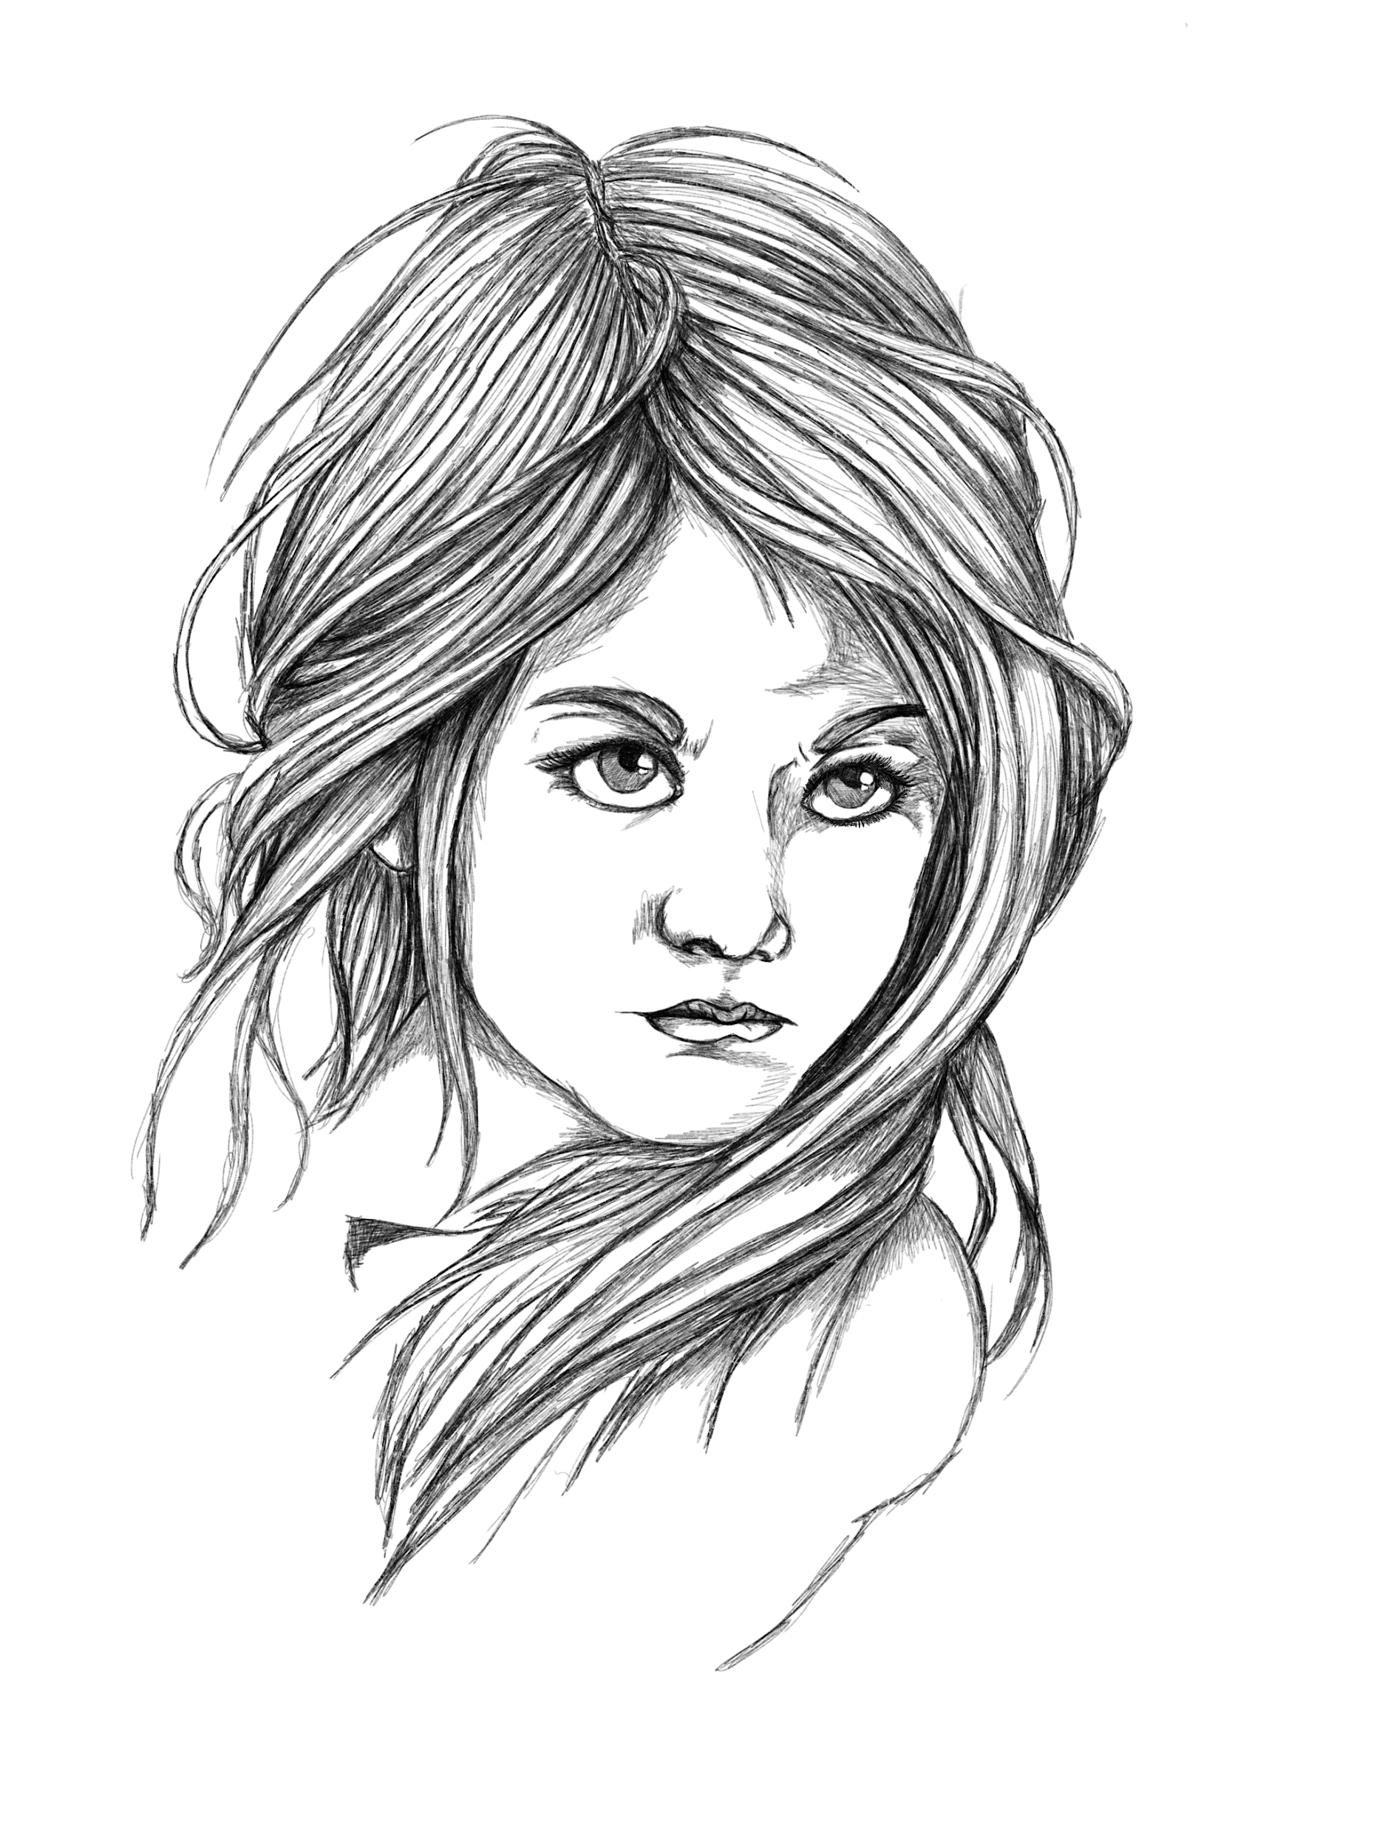
Levi
The resolute orphan
Strength: stubbornness - Object: Granite stone
Main relation: secretly in love with with Issa

I am the resolute orphan and my strength is stubbornness. My parents died when I was very young and an old woman has raised me ever since. But I have taken more care of her, than she of me. My life have not been easy, I have had to fight for every little thing. But I keep going, no matter what life throws at me. They will never break me.

What the others think of me:
Levi is an orphan but isn’t held back by that, or any thing else. Levi might not look like much, but don’t be fooled, Levi can will survive all the trials of life.

Relations
Main relation: Issa - Strength: Trust - Object: teddy bear - I think, I’m in love with Levi. But we come from such different worlds. Issa is from the richest family in town, but doesn’t t show it. Issa belices in the best in people. Issa must of course never know of my feelings, because Issa would never be interested in someone as poor and rough as me.

Milo and Nor
Milo og Nor are siblings. They may disagree a times, but they care deeply for each other.
- Milo - Strength: Joy of life - Object: Soap bubbles - The youngest on our group, and Nors younger sibling. Somewhat irresponsible but always excited about the world and life. Milos good mood is very infectious even though it can become a bit silly at times.
- Milo - Strength: Joy of life - Object: Soap bubbles - About the same age as Issa and Levi and is the older sibling to Milo. Nor always takes good care of Milo, and all of us come to think of it. If you are in need of care and support then you go to Nor.

Eli and Val
Eli and Val are best friends exactly because of their differences.
- Eli - Strength: Hopeful - Object: a light - Eli and Val are the oldest on our group, and therefore kinda our leaders. But it is well earned. Eli is always looking towards far horizons, and can talk forever about all the adventures that we will have.
- Val - Strength: responsibility - Object: A bottle of water - Val is Elis opposite, and that is why they do so well together. Val is focused inward towards Homestead and our group. Vel will never let us down, and takes the responsibility as eldest very seriously.

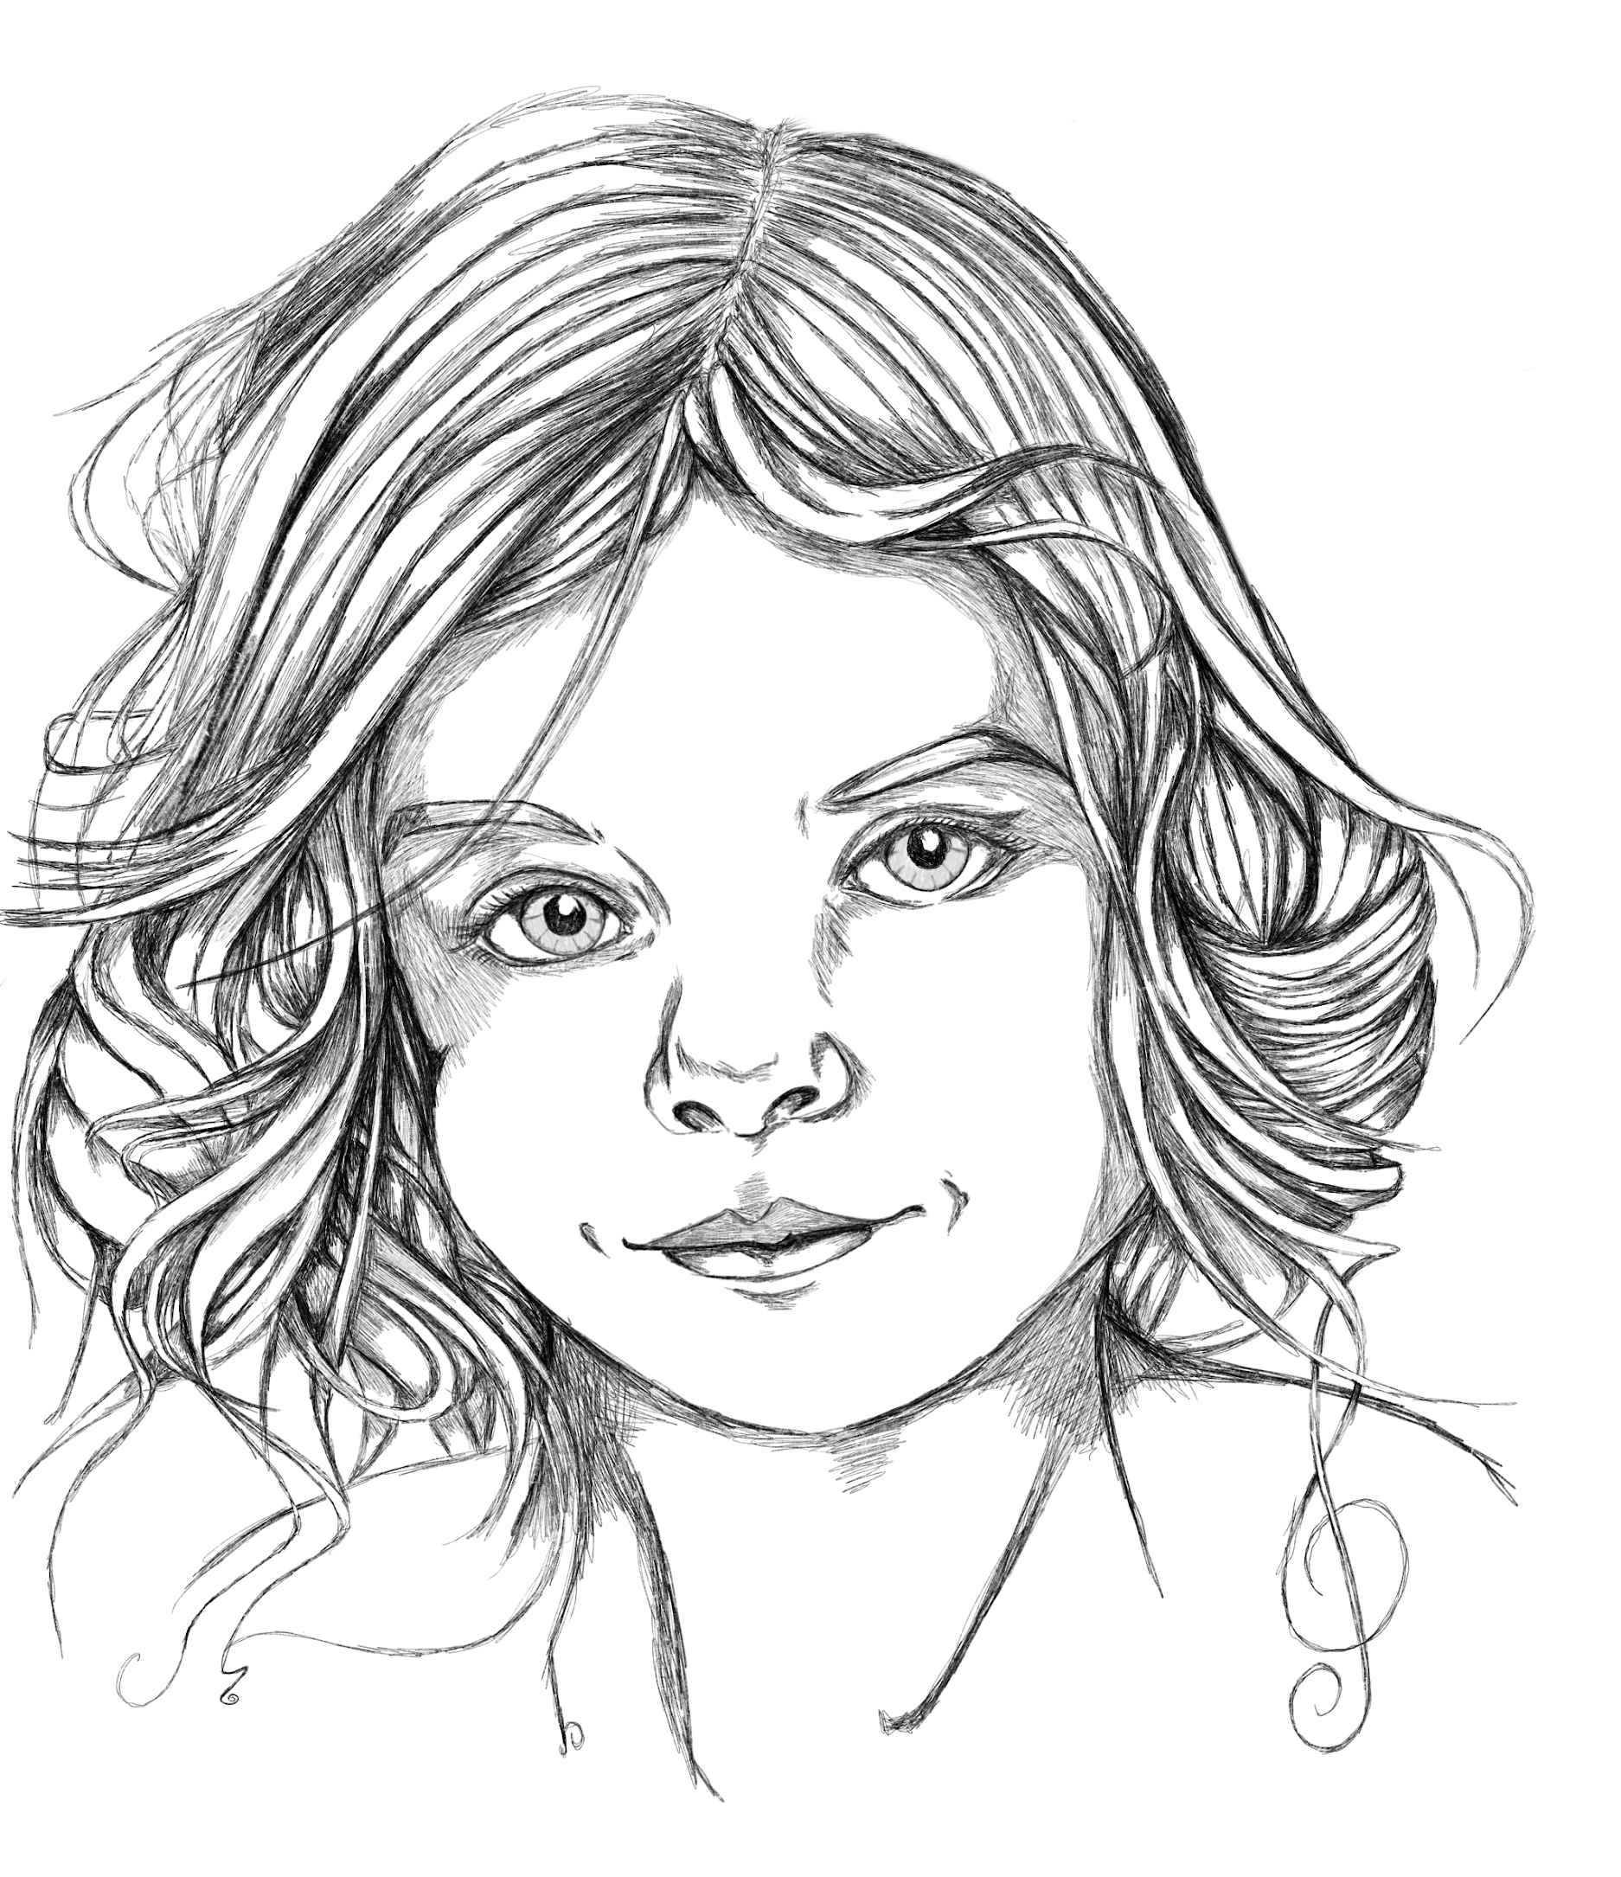
Eli
The adventurous leader
Strength: Hopeful - Object: a light
Main relation: Best friends with Val

I am the adventurous leader, and my strength is hope. I’ve always looked to the far horizon, and I believe that the future will be bright for us. It under sad circumstances that we have to leave our home, but I hope that this will all turn out for the best. I just know that it will end well, no matter what happens.

What the others think of me:
Eli and Val are the oldest on our group, and therefore kinda our leaders. But it is well earned. Eli is always looking towards far horizons, and can talk
forever about all the adventures that we will have.

Relations
Main relation: Val - Strength: responsibility - Object: A bottle of water - My best friend is Val. When we work together it feels like we can do anything, even though we are very different persons. Val has his gaze turned inwards and always takes care of the rest of us, where I more look outwards and onwards. We are the two oldest in our group and kind of its leaders.

Milo and Nor
Milo og Nor are siblings. They may disagree a times, but they care deeply for each other.
- Milo - Strength: Joy of life - Object: Soap bubbles - The youngest on our group, and Nors younger sibling. Somewhat irresponsible but always excited about the world and life. Milos good mood is very infectious even though it can become a bit silly at times.
- Milo - Strength: Joy of life - Object: Soap bubbles - About the same age as Issa and Levi and is the older sibling to Milo. Nor always takes good care of Milo, and all of us come to think of it. If you are in need of care and support then you go to Nor..

Issa and Levi
It seems that Issa and Levi like each other a lot. Everyone can see it except themselves.
- Issa - Strength: Trust - Object: teddy bear - About as old as Nor and Levi. A child from the richest family in Homestead. But you can’t tell, except that Issa might be a bit naive at times. But that is only because Issa always believes in the best in people. It feels good to be trusted by Issa.
- Levi - Strength: Stubbornness - Object: a granite rock - Levi is an orphan but isn’t held back by that, or any thing else. Levi might not look like much, but don’t be fooled, Levi can will survive all the trials of life.

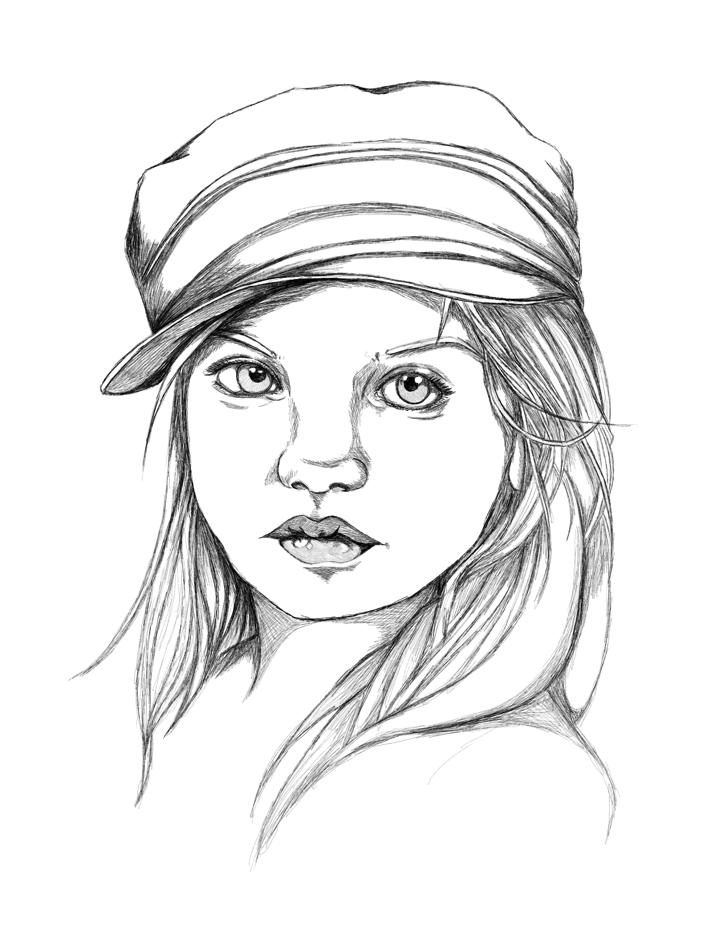
Val
The reluctant leader
Strength: responsibility - Object: A bottle of water
Main relation: Best friends with Eli

I am the reluctant leader and my strength is responsibility. I really didn’t want to leave. I don’t think I have what is needed of me. But now the burden have fallen on me, and I have to lift it. But that responsibility alone is enough to make sure that I will make it. My responsibility towards the others keeps me going, no matter what.

What the others think of me:
Val is Elis opposite, and that is why they do so well together. Val is focused inward towards Homestead and our group. Vel will never let us down, and takes the responsibility as eldest very seriously.

Relations
Main relation: Val - Strength: responsibility - Object: A bottle of water - My best friend is Val. When we work together it feels like we can do anything, even though we are very different persons. Eli looks towards the far horizon and always talks of the many adventures we are going to have, where as I more look inwards towards the group. We are the two oldest in our group and kind of its leaders.

Milo and Nor
Milo og Nor are siblings. They may disagree a times, but they care deeply for each other.
- Milo - Strength: Joy of life - Object: Soap bubbles - The youngest on our group, and Nors younger sibling. Somewhat irresponsible but always excited about the world and life. Milos good mood is very infectious even though it can become a bit silly at times.
- Milo - Strength: Joy of life - Object: Soap bubbles - About the same age as Issa and Levi and is the older sibling to Milo. Nor always takes good care of Milo, and all of us come to think of it. If you are in need of care and support then you go to Nor..

Issa and Levi
It seems that Issa and Levi like each other a lot. Everyone can see it except themselves.
- Issa - Strength: Trust - Object: teddy bear - About as old as Nor and Levi. A child from the richest family in Homestead. But you can’t tell, except that Issa might be a bit naive at times. But that is only because Issa always believes in the best in people. It feels good to be trusted by Issa.
- Levi - Strength: Stubbornness - Object: a granite rock - Levi is an orphan but isn’t held back by that, or any thing else. Levi might not look like much, but don’t be fooled, Levi can will survive all the trials of life.

