Blood and Iron: A Trick of the Light
A Victorian Steampunk Scenario of Adventure and Intrigue using a variation of the Victoriana system.

“Not through speeches and majority decisions will the great questions of the day be decided... but by iron and blood.”
Otto Von Bismarck

Game by Dudley Martin

Game Blurb:
The year is 1864. The rescued Britannian intelligence agent has dire news. The Prussian Thaumaturgical Academy is working for some dire underworld power. With that power they seek control of dark magiks to continue the fight for control of Europa. But all is not yet lost. Deep within the locked archives of the Academy library there lies a Grimoire, the Ars Theurgia Appollyonicus. You must venture into the dark heart of Prussian Thaumaturgy and retrieve it. Within it lies information needed to combat not only the Prussian Thaumaturges, but clues as to what or whom controls them. The fate of the Empire and all of its people lie within your hands. Are you ready?

Contents
Game Blurb: 2
System Basics 4
USING SKILLS 4
Characteristics 4
Effect and damage rolls 5
Combat: 5
INITIATIVE 5
What can I do as an action? 5
Melee & hand-to-hand attacks 6
Making the attack 6
Making the attack 6
Determining damage 6
ALL OUT DODGE 7
Taking cover 7
Diving for cover 7
EXPLOSIONS 7
Special Abilites 8
Sensate abilities 8
Miracles of Faith 9
THAUMATURGY SPELLS 9
Setting mood: 13
The Characters (For your information) 13
Opening Scene: Bad News and Worse News 14
Scene 2: Preparations 15
Scene 3: Infiltration 16
Scene 4: A Bustling Port Town 19
Scene 5: Into the dark Heart 19
Scene 6: The School Appears 24
Scene 7: The Library 27
Scene 8: Escape 29
Epilogue 33

System Basics

USING SKILLS
Whenever your character tries to do something (called taking an action), there’s always the question of whether he’ll succeed or fail. Sometimes the task is so easy that it’s obvious; for instance, taking a step forward without falling down. In those cases you’ll just tell the Gamemaster what you’re doing, and no die roll is needed. But if you’re trying to take a step on the deck of a ship pitching wildly in a driving rainstorm, walking might be very difficult indeed. That’s where task resolution comes in. All tasks in Victoriana are resolved with the same formula: take the relevant characteristic and add to it the relevant skill, then add the result of an action roll of 3d6 to create an ‘action total’. Compare your total to the difficulty of the task. If you equal or exceed the difficulty value, you succeed!

Characteristics
Intellect: for memory recall, problem solving, manipulating tools & instruments

Resolution: for the ability to face danger, fear, and stress

Presence: for interactions with others.

Dexterity: for fighting, dodging, athletics, driving, running, and swimming

Body: for using physical power, resisting pain, disease, shock

Your (characteristic + skill) + 3 dice in an action roll
Vs. The difficulty of the task
DIFFICULTY TABLE (for most rolls use an average difficulty. Use higher or lower depending on situation and action)
Easy | 10
Average | 14
Exasperating | 18
Really? | 22
Very | 26
Extremely | 30
Ridiculously | 34
Impossibly | 38

When you roll your action dice you may roll all sixes, if so then rejoice! This is known as a special success. In combat attacks this generally means that you double the damage done, in
other action rolls the gamemaster will tell you how your special success manifests. Adversely if your dice roll comes up with three 1’s then the attempt automatically failed, this is known as a foul failure.
Example: Mad Eric is fending off a footpad; it’s his turn to attack. He’s using a sword cane, so we add his dexterity 3 and swordplay 4 for a total of 7; the gamemaster tells Mike (Eric’s player)
that he will need to beat a difficulty of 22 to hit the thug. Mike makes his action roll and the dice
come up with a 2,4, and a 6. That’s a total of 19 – Eric Misses!

Effect and damage rolls
Effect rolls follow some action rolls; usually they represent damage done by weapons, or define the effects of a spell. You usually roll a set amount of effect dice and add the results together, just like an action roll. The difference to action rolls is that there are no skill or characteristic
bonuses to effect rolls Once rolled add the results together, this is the effect total, or damage roll as it is often known.

Combat:

INITIATIVE
At the beginning of each round, each character rolls 2 dice and adds their initiative characteristic in an action roll. The character with the highest total acts first for that round
(they are also allowed to hold their action and act later in the round). The character
with the next highest total acts next and so on. Roll an additional die to break ties; high
number goes first.

What can I do as an action?
You can do one thing with each action. In its simplest terms if there is a dice roll required it counts as an action. This
could include:
Combat Actions...
Draw a weapon
Make a single melee attack
Make a single ranged attack
Throw a stone or bomb
Move up to your full combat movement
Non-combat actions…
Make a small speech to intimidate or impress
Perform an athletics feat, such as leaping, or breaking down a door.
Cast a spell
Command an embodiment
Invoke a demon
Maintaining a spell with a concentration roll
Untying a captive
Opening a closed but unlocked door
Get up after being knocked prone
Each one of these things would be considered a single action.

Melee & hand-to-hand attacks
Melee represents up close and personal duels and brawls, opponents might be using swords, clubs, chair legs, frying pans, fists, feet, and perhaps even skill.

As a general rule melee range is considered to be 4yds, the typical reach of an adult arm and a
sword. If you want to start a fight you have to be at least this close.

Making the attack
An opposed action roll between the attacker and defender represents melee combat.
The attacker combines his dexterity, an appropriate weapon skill and an action
roll. He may also have to add or subtract certain modifiers from this action total to
determine the final outcome. The defender combines his dexterity, his dodge! Skill and the result of an action roll, the defender might also have modifiers to his roll before obtaining a final total. The final totals are compared, if the attacker has the higher score then he hit, and
should roll damage, if the defender has the highest total then he evaded the attack – this time. In the event of a tie, the defender always evades.

Making the attack
Unlike melee combat, ranged combat is an unopposed action roll by the attacker against a target number defined by range and possibly a modifier from all out dodge! Attempts.
The attacker combines his dexterity, the appropriate weapon skill and an action
roll. The action total is compared to the difficulty as defined by the range if you equal
or exceed the difficulty of the shot you hit and roll damage.

RANGE & DIFFICULTY TO HIT
Range | Difficulty
Point blank (4yds or less) | 10
Close (10yds or less) | 14
Medium (50yds or less) | 18
Long (out to listed range of weapon) | 22
Extreme (beyond listed range) | 26
+ 2 per + 100yds

(It is suggested that for ease of con play that all rates of fire be limited to 1 or 2)

Determining damage
Once you have made a successful attack the next step is to determine the amount of damage your attack has done to your opponent. Damage rolls are effect rolls, and are dealt with as follows. The weapon used dictates the amount of damage you will do. Few people died from gunshots in this era, most died from infections in the wound days or weeks later. Once you have determined the amount of damage dice to be rolled, roll them and add the results together, this is your damage total. Every character or creature in Victoriana has a fortitude characteristic, some will also possess armour, whether worn or as a natural feature. The defender subtracts
both his fortitude rating, and the rating of any armour he is wearing from the damage
total, the rest is applied to his health scores.

ALL OUT DODGE
Use this action to make yourself harder to hit. As your first action you declare an all out dodge,
and in your initiative order for the first action you make a complementary roll on dexterity + dodge! With a difficulty of 14. The result of this complementary roll is added to each of your automatic defence rolls for that round. See complementary skills in the skills section for more information.

Taking cover
If you don’t want to waste an action racing around to facilitate an all out dodge, you can try
to take cover. By using the environment around you such as trees, walls, and even furniture, you can reduce your opponent’s chances of hitting you in ranged combat, see the modifiers section for examples. You cannot take cover from the environment in melee combat; you and your opponent are too closely engaged to be able to do so, but you can use portable items such as furniture as improvised shields if your gamemaster allows.

Diving for cover
This variant of all out dodge can be used to avoid sudden and unexpected area effect attacks such as explosions and some spells. You make an action roll using athletics against a difficulty based on the distance (base of 14 for 1yd + 1 difficulty for every extra 1yd). If the roll is failed, you didn’t dodge fast and/or far enough and were caught by the attack effects. Diving for cover is usually a free action and once performed is the last action of the round for that character as he then picks himself up from the debris. However a character with enough foresight (or paranoia) can specify diving for cover as an action (just in case), and
characters who do so may then continue to act in the round as normal.

EXPLOSIONS
Attacks that strike an area rather than a character (bombs, grenades, gas and other effects) are known as area effect attacks. The area affected depends on the damage dice of the attack being used, typically this is a 1 yard radius per damage dice of the weapon, and will always be described as part of its description or construction. The outcome of area effect attacks is determined by each defender in the area defending against a single attack total by diving for cover; those who fail take damage. Ground zero of an explosion or area effect takes the full damage of the attack, characters take 2 less points of damage for every yard they are away from the centre of the attack. Character who are outside the area of effect, take no damage at
all.

ENVIRONMENTAL INTENSITIES
Type | Mild | Intense | Deadly
Damage | 1-4 dice | 5-10 dice | 11-20 dice
Electricity | Battery | Generator | Lightning bolt
Illness | Measles | Cholera | Plague
Drug | Alcohol | Opium | Cocaine
Poison | Belladonna | Arsenic | Stonefish venom
Fire | Wood fire | Gas fire | Chemical fire

Special Abilites

Sensate abilities
Sensates have a strong connection to the natural world, and their gifts reflect their super sensitive
nature allowing them to see what others do not.
Ability Difficulty Description
Aura reading 14 A successful medium + presence roll allows the medium
to gauge the mood, temper & intentions of the observed
person. Aura reading is only applied to individuals, not
to groups. One aura reading can be conducted with one
action.
Glimpse 26 By using this power the medium is hit with a powerful
and vivid vision of an event that is due to happen. The
medium has little control over what he sees (you cant try to
see the outcome of this years grand national), but you can
be confident that it is imminent, certainly within the next
week.
Know recent events 22 A successful action roll grants knowledge of recent events
occurring around the person or object being studied. The
nature of the knowledge gleaned from such an observation
is often incomplete and fragmented, often, information is
only trivial and not of obvious use.
Magic sense 18 The games master makes this roll whenever the character
comes within 10 yards of a spell effect; focus, magical
artefact or sorcerer. Magical creatures such as demons are
not detected by this ability. With success the character is
aware of a tingling sensation down the spine, warning the
character of magical presence. An excellent success might
yield information concerning the nature of the magical
presence.
Psychometry 22 The ability to gain information concerning an individual
from their personal effects. Information accessible usually
relates to the individual’s present welfare or location, but
information about the recent well being and transitions of
the items owner may also be gleaned.
Sense the supernatural 14 The medium can sense supernatural beings such as
demons, ghosts and the invisible within 10 yards. Exact
location cannot be discerned, although a good idea of
direction is furnished.
Sixth sense 14 An uncanny & instinctive knowledge of events around the
corner. With use of this ability a medium may finish the
sentences of others. Also sixth sense may be used to avoid

Miracles of Faith
Ability Difficulty Description
Heal 18 The medium can call upon the mercy of heaven
to heal a deadly wound or disease. Heals 3d6 points of damage completely.

THAUMATURGY SPELLS
Botheration
Resolve cost: 1 (18)
Range: touch
Duration: rounds
Once cast the target must be touched, and a opposed roll between resolution
+ thaumaturgy and resolution + concentration ensues. If successful the target
becomes totally confused. A bothered target cannot concentrate on even
simple tasks, represented by a –6 action roll modifier.
Darkness of ages
Resolve cost: 2 (22)
Range: 20 yds
Duration: minutes
Creates a billowing black cloud of absolute darkness. From outside the spells
5 yard radius the cloud appears to be thick roiling smoke. From within there
is absolute darkness, with no suggestion of smoke or a gas of any kind.
Ectoplasmic bonds
Resolve cost: 4 (24)
Range: 40 yds
Duration: hours
Tendrils of Ectoplasmic slime materialise to ensnare the target of this spell.
The bonds may stick a target to a surface such as a wall, floor or ceiling.
Breaking free from the slime requires a body + athletics (32) roll. Winning
breaks free, losing remains entangled. After 2 hours the slime starts to lose
coherence, and the difficulty drops by 4 each half hour from that point until
the end of the duration.
Farspeech
Resolve cost: 1 (20)
Range: sight
Duration: instant
This spell allows whispered conversation to be passed as far as the
eye can see. As long as the target can be seen they can hear the
caster’s words. This spell does not grant two-way communications.

Etheric bolt
Resolve cost: 4 (24)
Range: 20 yds
Duration: instant
Upon completion of the spell, an etheric bolt of green energy forms
around the casters hand, which may then be fired with dexterity + thaumaturgy
in the same manner as mundane ranged attacks. The bolt does
4 dice of lethal damage. Etheric bolt is not resisted with resolution; the
rules for dodging ranged attacks apply. One casting provides one bolt.
Etheric bludgeon
Resolve cost: 2 (22)
Range: 20 yds
Duration: instant
Upon completion of the spell, a pale bolt of energy forms around the
casters hand, which may then be fired with dexterity + thaumaturgy in
the same manner as mundane ranged attacks. The bolt does 4 dice of stun
damage. The bolt is not resisted with resolution; the rules for dodging
ranged attacks apply. One casting provides one bolt.
Firespark
Resolve cost: 1 (20)
Range: self
Duration: instant
A small gas flame appears from the finger or thumb of the caster. The
flame lasts several seconds and is sufficient to light a pipe, cigarette,
lamp, candle or fire.
Etheric barrage
Resolve cost: 6* (26)
Range: 100 yds
Duration: rounds
This spell channels energy around the sorcerer and then through him into
a seething stream of fire, which may then be fired with dexterity + thaumaturgy
in the same manner as mundane ranged attacks. The caster can
throw any amount of barrages from one casting, but each bolt after the
first costs an additional 2 resolve. Should the Thaumaturge foul with any
roll when using this spell, the caster will suffer a full strength barrage hit
himself.
Each barrage does 6 dice of lethal damage. Barrages are not resisted with
resolution; the rules for dodging ranged attacks apply. One casting provides
unlimited bolts for the duration.

Flight of the wyvern
Resolve cost: 3 (22)
Range: self
Duration: minutes
The caster can command ethereal forces to counterbalance the forces of
gravity, thereby granting the power of flight. The caster gains a flying
combat speed of 16 yards/round. As the air is not a native element to
mankind, flight is slow and unsteady at first, with manoeuvres relying on
intellect alone. Frequent flyers however, may study the speciality: flight
skill.
Levitate
Resolve cost: 2 (20)
Range: 10 yds
Duration: rounds
The caster can command ethereal forces to counterbalance the forces
of gravity, allowing the levitation of himself, or other persons and
objects. No object may be raised higher that 6 yards from the ground,
and no more objects than the casters intellect may be raised at one time.
Levitation simply moves objects upwards; it confers no further movement
ability.
Gaslight
Resolve cost: 1 (18)
Range: 4 yds
Duration: minutes
Creates a small
ball of light in
the caster’s hand.
The light has the
power of a good
gas lamp and illuminates
approx
5 yards radius.
The ball can float
and may be mentally
directed by
the caster to any
position within
range.

Groom
Resolve cost: 1 (18)
Range: self
Duration: instant
This spell washes, refreshes, oils and combs hair, trims the moustache,
even dusts down and presses the caster’s clothes. Observers will see
the caster improving in appearance as if tended to by invisible hands,
with creases and folds in clothing ironing out while still worn.
Hair of the dog
Resolve cost: 2 (26)
Range: touch
Duration: hours
The caster must incant the formula to this spell loudly in Latin, upon
completion all the targets hangover symptoms are gone. The spell expels
headache, dizziness, lethargy, curried eyes, and bowel trouble. Note that
none of the above symptoms can be dispelled unless they are symptoms
of a hangover.
Heal
Resolve cost: 4 (22)
Range: touch
Duration: instant
This spell instantly knits flesh and dispels infection, healing 4d6 health.
The application of this spell has made the guild renowned as miracle
healers. Diseases cannot be treated with heal, they must be treated with
cure
Cure
Resolve cost: 6 (26)
Range: touch
Duration: instant
This spell instantly cleanses the target of any resident diseases or infections
that might be afflicting them. Poisons and physical wounds cannot
be treated with cure.
Instant beauty
Resolve cost: 2 (22)
Range: touch
Duration: hours
Increases the desirability of the recipient. No discernible change occurs, but others find the recipient attractive anyway, possibly being puzzled as to why. Presence increases by 2 for the duration.

Magic tobacconist
Resolve cost: 1 (18)
Range: self
Duration: instant
Allows the caster to magically produce a fine cigar or cigarette.
Alternatively the spell might be used to magically fill a pipe bowl.
Power of steam
Resolve cost: 3 (22)
Range: touch
Duration: minutes
The caster may confer the motive power of a steam train into a vehicle. When travelling in such a manner multi hued steam pours from the vehicle, often obscuring sight (-2 to driving rolls).
If applied to a person, their running speed is doubled and they gain +2 body. However, they also go bright red as magical steam gushes from ears, mouth, nose and through the seams of clothing. Living creatures take 1d6 stun each minute as a result of the unnatural exertions the body undergoes in this state.
Scholar’s guard
Resolve cost: 1 (20)
Range: touch
Duration: hours
The caster traces an imaginary perimeter with pointed finger. The perimeter may be up to 3 yards radius. Anything stepping through the perimeter sets off a magical alarm. The nature of the highly audible alarm is left to the caster.
Second sight
Resolve cost: 2 (20)
Range: self
Duration: rounds
Allows the caster to see supernatural effects clearly. Such phenomena include: possessing demons appear as if fully manifested through second sight. Spells effects appear as glowing energy and their nature may be discerned with scrutinise rolls. Creatures such as ghosts are always visible through second sight. While second sight is active, mundane sight is dim and darkened – all perception tests relating to the mundane world are at –4 modifier.

Spyglass eyes
Resolve cost: 1 (20)
Range: self
Duration: minutes
Allows the caster to see with up to x20 magnification, as if using a powerful
spyglass. The spyglass effect may be turned on or off during the
duration.
Steely skin
Resolve cost: 5 (24)
Range: touch
Duration: minutes
The spell weaves an invisible shroud of magical energy about the recipient,
granting an armour value of 10, which is added to any other armour worn.
The emperor’s new spell
Resolve cost: 4 (24)
Range: self
Duration: minutes
Renders the caster totallyinvisible to normal sight. Some creatures and use
of second sight spell will detect the caster. The spell will only render the body
invisible, clothes and items are not invisible unless swallowed or otherwise
enclosed in a body cavity.
True door
Resolve cost: 2 (20)
Range: touch
Duration: hours
This spell is cast upon a portal such as a door, window, box lid or other such scalable opening. The magic of the spell permeates the material of the portal and knits it together with strong, magic glue. The portal can no longer be opened normally, and must be forced.

Setting mood:
This game takes place during a time of change and growth. In this world the British Empire is expanding with the aid of steam power.
The gap between rich and poor is even more pronounced and should be played up. The rich will be light, airy, and clean, while the poor will be dark, dingy and filled with sooty smoke. Poverty abounds and the chances for advancement are not possible, while the upper classes live well beyond their means and utilize the poor as stepping stones to fame and fortune.
This game is all about the story and letting the players become part of that story. Encourage the players to describe their actions and to get into character with their roles. The story is loosely described, but should not be held to strictly. Allow the players to be inventive and if that leads them in different directions use the information here to modify the game and lay to that direction.
Above all have fun.
(For ease of the scenario assume all characters can speak some basic German)

The Characters (For your information)
Hawkeye: An archer extraordinaire. He can hit a half pence piece from half a mile away. He is a loner and doesn’t bathe much but is a deadly shot.
Alexander D'Amberville: A high class thief and martial artist.
Amelia Carradine: A high class thief, thaumaturge and book lover.
Diana Lann: An excellent if a bit angry engineer.
Ezra Deegan: A smuggler and owner of his own airship.
Elizabeth Riley: A revolutionary and explosives expert.
Dalia Wolhaus: A young Medium/Enchanteress
Rev: A Reverend who solves his problems with his fists and his God.

Opening Scene: Bad News and Worse News

One of the best in Brittanian intelligence. He was captured by the Prussians and locked up in their high security prison, Colditz. He has been rescued by the party, after a good deal of torture, but before he could give up his information. He is the only source of info regarding the Prussian Thaumaturgical academy.
Agent Ezekiel Fallion

The scene opens in the hold of the airship. Agent Fallon sits bandaged and in some pain. He looks up at the group. ‘Thank you for your rescue. I am not sure how much longer I could have held out.’ ‘I was investigating their Thaumaturgical academy when I was taken by a group of Thaumaturges in the forest. I had been successful in getting the basic location, and news on some of the defenses. Unfortuantely I think one of my contacts in Danzig betrayed me to them. I would not trust any of the standard contacts there.

He gives the party these main points of information (either give them the bullet points or include it in a speech from him, whichever works better).
​
- Academy located in forest 25 miles west of Danzig
- Hidden by spells so cannot be seen from air
- Will need to travel into the forest to locate it.
- Protected by patrols of thaumaturges and hellhound packs as well as magic wards.
- Will need signet ring from a current student or instructor to be able to pass through wards.
- There is a creature in the forest that could be helpful, but it is capricious.
- There is a guardian creature in the woods as well. Be warned.
- Do not have a layout or map as he was captured prior to locating the school.
- Information gathered leads to estimates of 50-100 students and 10-15 staff
- Ars Theurgia Appollyonicus, has information on the mastermind behind the Prussian government. Lies within a locked vault in the Academy library.

Scene 2: Preparations
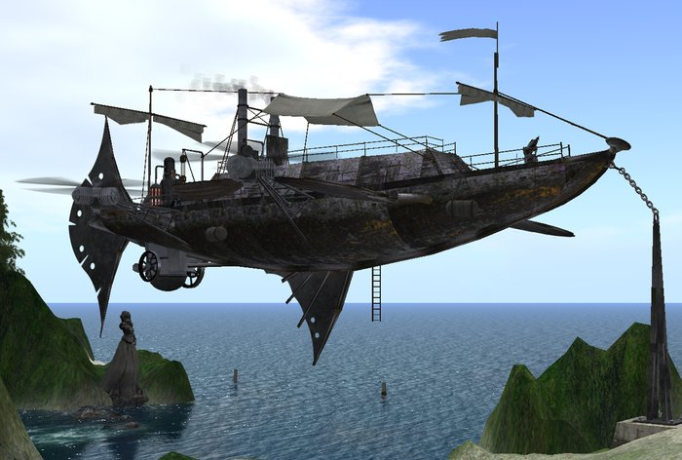

This is the time for the party to begin to plan how they want to accomplish this mission and how they are going to get away. (this is of course optional. They do not have to have plans before they go in)
They need to work out a few key things before they can begin the mission.
- How are they infiltrating?
- Will they take time to observe the Prussian routine to find ways to exploit it?
- How will they escape?
- What do they need to get to get in?
- How much time will they take? How much time do they have?

Scene 3: Infiltration
The players should work out how they will decide to infiltrate Prussian airspace. The easiest way will be for Ezra to get a legitimate cargo to enter into the port city of Danzig. This can be easily accomplished with a number of businesses in northeastern France looking to ship such things as food, and raw materials for industrial projects. Even with a legitimate cargo the ship will be stopped by Prussian picket ships where they will search the ship, look over the cargo manifest, and check the crew list. If they do not cause any problems, they will be sent on their way. If trouble starts, use the stats below. (if time considerations come into play move through this part without any conflicts)
*Unless they board the ship they are at a disadvantage. Their freighter is unarmed, leaving them with only their own small arms to defend the ship. The Prussian Pickett ship has air to air torpedoes, 2 Maxim machine guns and a Hotchkiss Revolving Cannon. At a distance it will be very difficult for the party to defend against these. If they try to fight and find that they are overmatched, give them an opening to escape. If they persist then they get what they deserve. (I will not give specific stats for the ships, use your own feelings on how much damage they can take. But the freighter can take only a fraction of what the pickett ship can)
Air to air torpedoes: (roll 3d6 diff 10 to target) on hit explode for 12d6 damage
Maxim machine gun: (roll 3d6 diff 6 to target) deals 3d6 damage over area. Characters can roll a Dex+Dodge diff 22 for half damage.
Hotchkiss Revolving Cannon: (roll 3d6 diff 8 to target) deals 5d6 damage over area. Characters can roll a Dex+Dodge diff 25 for half damage.
*If they board they must fight the Prussian Marines (Use the stats below)
Prussian Officer: Mental competence: 10 Physical competence: 10 Init: 10+2d6
Health: 55/7 inc greatcoat
Skill picks: Perception (10) , Dodge (10), Intimidate (8)
Combat picks: Sabre(16) for 4d6+6 lethal, Pistol (15) 5d6 Lethal
Prussian Soldiers with carbines (10) : Mental competence: 6 Physical competence: 10 Init: 8+2d6
Health: 35/7 inc greatcoat
Skill picks: Perception (10)
Combat picks: Carbine (16) for 5d6 lethal
Prussian Pickett Ship
The arrow on the map marks the location of the Prussian Thaumaturgical Academy.
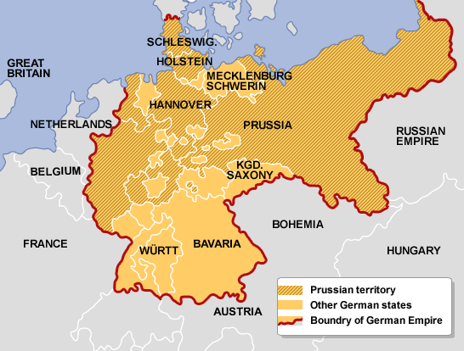

Scene 4: A Bustling Port Town
Danzig lies deep in the heart of Prussian territory. It is a busy trading city with numerous ship yards and airship yards. There is a strong military presence here. Supplies can be gained here but there is a chance of spies taking an interest in the party and their activities (this depends on how they go about their business, what they get and how they handle themselves.) Any problems with the locals or military will get the attention of the intelligence service.
Prussian Agent: Mental competence: 12 Physical competence: 12 Init: 10+2d6
Health: 55/7 inc greatcoat
Skill picks: Perception (10) , Dodge (10), Intimidate (8) Bureaucracy (10), Hide & sneak (12)
Combat picks: Pistol (15) 5d6 Lethal, Dagger (13)
Will attempt to follow and record activities. Will need a perception check of 22 to notice.
Prussian Intelligence Agent

Scene 5: Into the dark Heart

The forest surrounding the academy is a dark and overgrown affair. There are numerous paths and routes through the woods with most leading to bogs, pitfalls or dead ends. To successfully navigate the forest, the players will need to roll one of the following:
Intellect + Navigation (25)
Intellect + Survival (22)
Intellect + Perception (28)
Resolution + Thaumaturgy (25)

Out of five rolls three must be successes or the party will become lost. While lost there are three different encounters they may have. If they make the rolls have them encounter the Cat and go from there.

Roving patrols of Thaumatuges
As the party moves within the forest they have the chance of meeting a roving Thaumaturge patrol.
Consisting of four men (use thaumaturge stats) and six hellhounds. They will be looking for thaumaturgical activity.
Hellhounds (6) Mental 7 Physical 10 ;Health 60; Armour 10; Initiative 12+3d6; claws (18) 4d6, bite (20) 6d6
Prussian Thaumatuge: Mental competence: 16 Physical competence: 6
Health: 15/7 inc greatcoat
Skill picks: Thaumaturgy (16), occult (18), chemistry (16), medicine (14), astronomy (16),
Research (16), linguistics (16)
Combat picks: Walking stick (6) for 3d+3 stun, etheric bolt (16) for 4d lethal, etheric bludgeon (16) for 4d stun, power of steam (16), heal (16)
Loot: Signet rings to bypass protection wards.
Prussian Thaumaturges
Prussian Student Signet rings
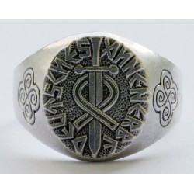

A Capricious Encounter

As the party wanders through the forest they can encounter the cat. It will make its presence known by laughing or snickering as the party attempts to navigate. It may even make snide comments on individual party members, on how they are not dressed for the woods, how incompetent they are. If questioned it will respond with more questions or just nonsensical sayings. Play this as a humorous encounter. If treated well the cat can lead them to the academy, but will warn them it will do no good if they do not have the signet rings to get in. If they do not have them, it can and will lead them to a patrol where they can be obtained. If they have not encountered the Bandersnatch it will warn them of wandering and will direct them away from it, unless they have been rude, then it will guide them directly to the Bandersantch, disappearing with a smile and saying the it hopes they have a winxy pistol.

The Cat does not need any stats as the party cannot harm it despite their best efforts. It can disappear and reappear at will and can disconnect body parts. It is immune to thaumaturgy and will make snide comments on whoever tries to attack it. If they really annoy it, the cat will follow them and set of traps and alarms making the whole process much more difficult. (each time an alarm goes off send in a squad of thaumaturges and hellhounds.)

The Frumious Bandersnatch
Mental: 10 Physical : 20
Health: 200 Armour:20
Abilities: Darkvision, Blindsense, Lowlight Vision, Immunity Poison, Heals 15 hits per turn.
Skills: Athletics (15), Dodge (12), Survival (15), Perception (15), Hide & Sneak (20)
Attacks : Claw (15) 6d6 Pounce (12) 4d6 Rend (4 claws) (15) 8d6

Bandersnatches are consummate hunters, and only the deadliest predators or the most cunning intelligent prey offer them sport. Once a bandersnatch has marked a creature for death, it runs it to ground without fear, rest, or remorse.
Bandersnatches rely on speed, shock, and terror to bring down prey. They pace their quarry from a distance, hidden among the trees, then break from cover, savage their target, and dart away again. They drag smaller creatures away to dispatch at leisure, while engaging larger ones in skirmishes until they gradually wear their prey down. An outmatched bandersnatch withdraws at full speed, stopping only to pick off pursuers that distance themselves from their allies. Once its wounds heal, the bandersnatch returns to the scene of its defeat, picks up the trail of its assailants, and eliminates them one by one.
The Frumious Bandersnatch
The party will encounter the Bandersnatch in a thick part of the forest where vision is impaired and movement is limited. It will attempt to target the weakest party member (usually Dahlia). It will follow for a few minutes before attacking. Give the party perception +intellect diff 25 or intellect + survival diff 20 to notice and be able to prepare for the attack. If the Bandersnatch is heavily wounded it will attempt to escape, heal and come after them again later. Use this encounter as you will.

Scene 6: The School Appears
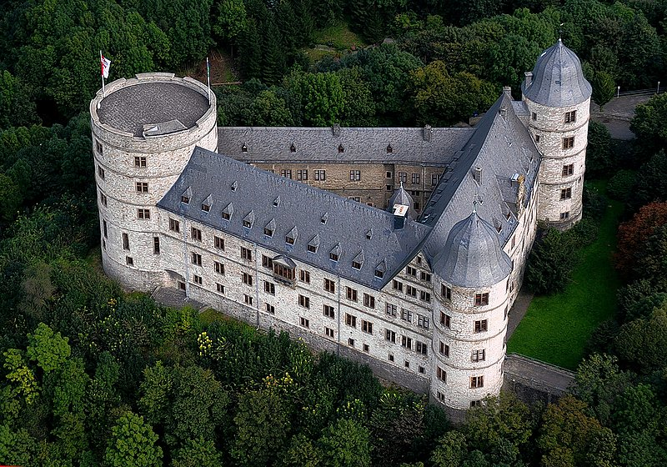
The academy lies with the forest. The castle sits within a large grove and has only one entrance.
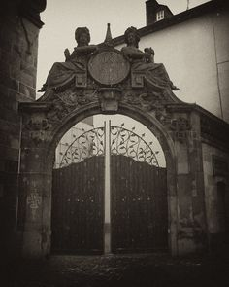If they have the signets the eyes of the figures above the entrance will glow green. If they try to infiltrate without the signets the eyes will glow red and a magical alarm will go off summoning the entire student body and staff to repel invaders. (this is not a fight for the party to stick around for)
Once inside layout of the academy becomes clear. There are numerous pens for the hellhounds and signs in German for the main hall, the headmaster’s office, classrooms and the library. For most encounters with students or staff use the general Prussian Thaumaturge stats below.
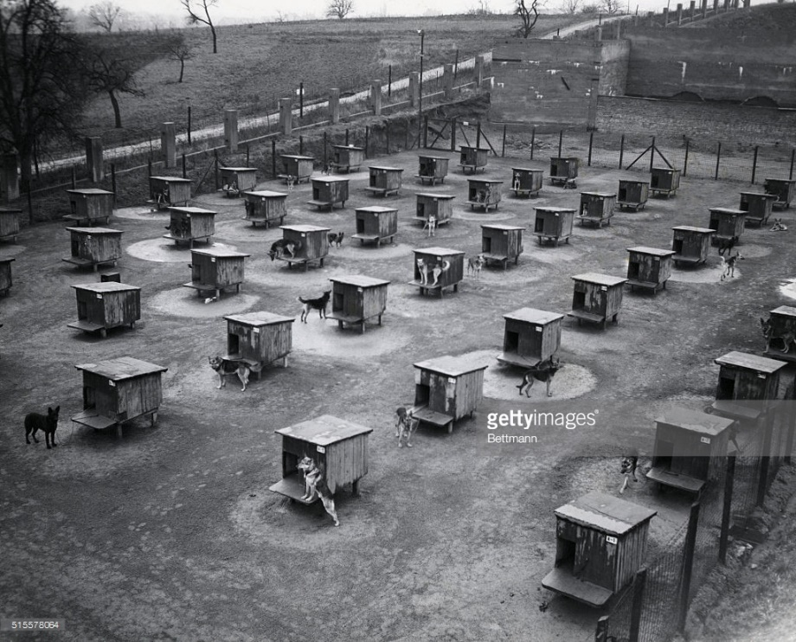
Hellhound pens.

Prussian Thaumatuge: Mental competence: 16 Physical competence: 6
Health: 15/7 inc greatcoat
Skill picks: Thaumaturgy (16), occult (18), chemistry (16), medicine (14), astronomy (16),
Research (16), linguistics (16)
Combat picks: Walking stick (6) for 3d+3 stun, etheric bolt (16) for 4d lethal, etheric bludgeon (16) for 4d stun, power of steam (16), heal (16)
Prussian Thaumaturges

Scene 7: The Library

The library is a massive underground edifice. Anyone with a signet ring will be allowed to wander about the stacks. There is a locked vault which if protected by the librarians. A search amongst the stacks will reveal (with a successful roll of 3d6 diff 10) a number of interesting books:
- The Labyrinth: The story of a young woman who travels into the Labyrinth to face Jareth and to recover her lost little brother. Hidden within are secrets to dealing with the Goblin King.
- Revelations of Glaaki: The Revelations of Glaaki are the name given to a collection of twelve volumes written by the members of the undead cult of Glaaki.
- De Vermis Mysteriis: De Vermis Mysteriis is the work of one Ludvig Prinn; a Flemish alchemist and supposed sorcerer. Prinn had spent a great deal of time traveling in the east (particularly in Syria and Eygpt) and claimed to have obtained a great age through the use of his sorcery.
- Occultus Deus: Written some time in the 16th Century, this handwritten Latin book contains a partially incoherent and rambling discourse on several of the most powerful 'beings' in the universe.
- Cultes des Goules: Catalogues a large cult practicing necromancy, necrophagy, and necrophilia in France.

In order to gain access to the vault the librarians must be dealt with.
Prussian Thaumatuge: Mental competence: 16 Physical competence: 10
Health: 35/7 inc greatcoat
Skill picks: Thaumaturgy (20), occult (22), chemistry (16), medicine (14), astronomy (16),
Research (26), linguistics (16) , Dodge (15), Hide & Sneak (15), Perception (20)
Combat picks: Combat Staff (16) for 3d+3 stun, etheric bolt (20) for 4d lethal, etheric bludgeon (20) for 4d stun, power of steam (20), heal (20), Etheric Barrage (20) 6d6 AOE Lethal, Darkness of Ages (20),

Amulet that functions as key to the vault.
Prussian Librarians

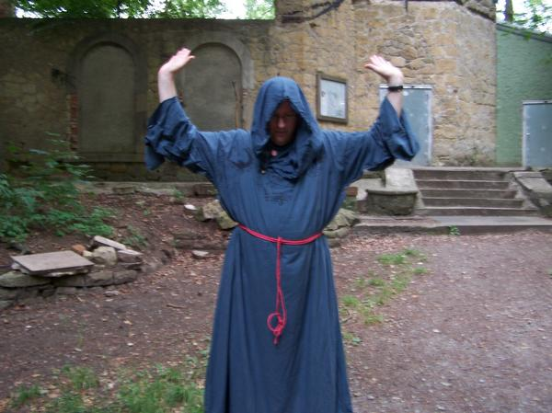
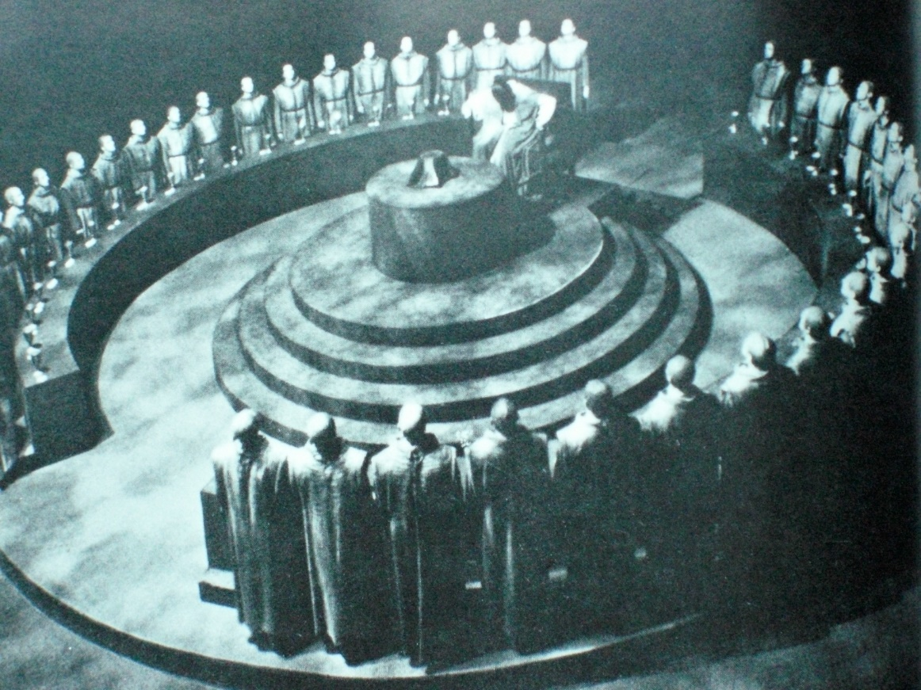
Within the vault lies the copy of Ars Theurgia Appollyonicus guarded by statues of Teutonic Knights. This book after a period of study (at least one hour) talks about the fallen angel Apollyon. It describes his thirst for power and how he is willing to use any earthly power as a means to return to heaven and conquer it. It requires much more study to identify any weaknesses or ways to defeat Apollyon. With proper study the Royal Academy (or the players themselves) will be able to develop a plan to counter Apollyon’s plans and stop his menacing of Europa.

Give them some time to investigate and scare them with the guardian statues. But save any combat for the next scene. Allow them to make perception checks diff 25 to hear the alarms from above. If they do not notice before they leave have the cat appear and snarkily inform them of the reception awaiting them.

Scene 8: Escape
The party knows that the members of the academy await their exit from the library. Allow them time to decide how they will escape. Keep an eye on the time that they have taken to put their plans into action.
Again let them decide their own fate. Give them the freedom to try whatever foolhardy plan they wish to. If they describe it well and make a good story out of it, go with it. Make it difficult, but let them make some rolls (a 3d6 luck roll with a choice of high or low works well for me) and see how it comes out. Above all let them have fun.

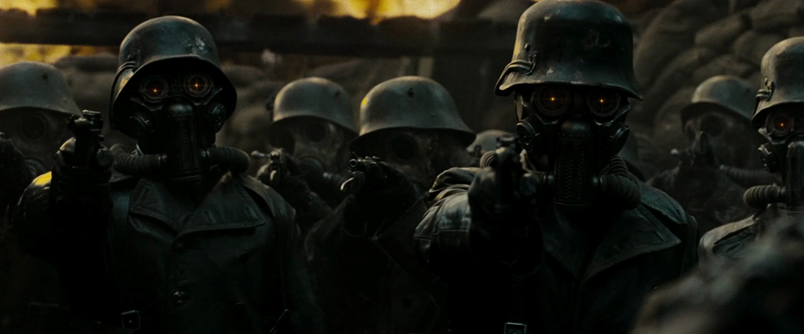

Awaiting the players outside of the library is an arrogant looking man in robes. He sneers at the players as they emerge. Surrounding him are a number of heavily armed Prussian automatons (half again more than the members of the party).
Headmaster Lucius
‘Found what you were looking for? How nice. Know that you will never leave here alive to enjoy your triumph. Kill Them!’

Play this as a very action movie type scene. Try to make sure everyone can be involved (and should be involved as the opponents are dangerous). As this is the final battle have fun with it and get the players excited. Make this fight difficult. Allow the players to be creative (encourage creativity), but if they make mistakes they should suffer for them. If any are taken down they are not killed, but instead are captured. (this could lead to the next episode being the rescue of those captured.) have fun. If they escape have them describe what they do and how they make it back to the airship.
HEADMASTER LUCIUS: Mental competence: 16 Physical competence: 10
Health: 35/7 inc greatcoat/Magic Shield 100
Skill picks: Thaumaturgy (20), occult (22), chemistry (16), medicine (14), astronomy (16),
Research (26), linguistics (16) , Dodge (15), Hide & Sneak (15), Perception (20)
Combat picks: Combat Staff (16) for 3d+3 stun, etheric bolt (20) for 4d lethal, etheric bludgeon (20) for 4d stun, power of steam (20), heal (20), Etheric Barrage (20) 6d6 AOE Lethal, Darkness of Ages (20),
The Special Forces are silent figures in Dark Black Prussian uniforms with their faces covered. They will respond to danger very quickly and interpose itself between harm and the Headmaster.
(For any skill checks use the mental or physical base + skill + 3d6) initiative for Bodyguard is 14 +2d6
It has a health of 85 and 20 Armour for the body and 15 for the head.
Mental:4 Physical :9 Skills: Perception (9) , Combat: Sabre (15) 4d6+9 Lethal, Pistol (15) 3d6 Lethal, hammerfist (16) 5d6 Stun, Assault Carbine (15) 5d6 Lethal

Headmaster Lucius and His ‘men’

[Grab your reader’s attention with a great quote from the document or use this space to emphasize a key point. To place this text box anywhere on the page, just drag it.]

Epilogue

The air rushes past your faces as the airship speeds away from Prussia. The sun rises and a peace descends upon the sky. Despite all the troubles that you have been through, it is a good day. You have earned your payment and you are still flying.

